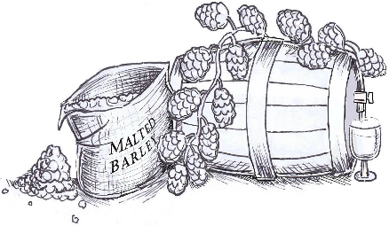 |  | Bridbrewer and Taproom  Bottled & Cask Beers  Beers Currently Available  Updated Wednesday 13th July  Ready To Drink:-  Banana Rum & Sultana 4.5%  Beerscoff 4.9%  Citra 4%  Hoppy In Brid 4.6%  Mosaic 4.2%  Orange & Coriander 4.6%  Raspberry Wheat 4.2%  Strawberry Milkshake Max 4%  Whisky Pilsner 4.5%  Alan’s Thriller In Vanilla 4.8%  Morello Cherry Porter 4.8%  Salted Crème Caramel Porter 4.8%  Wild Blueberry Porter 4.6%  Blackberry Stout 4.4%  Jan’s Jaffa Cake 4.5%  Oystercatcher 4.6%  Rum & Raisin Oatmeal Stout 4.2%  Smoke Me A Cherry 4.2%  King Street IPA 5%  Rye 4.9%  Cask Beers  Hoppy In Brid 4.6%  Banana Rum & Sultana 4.5%  Rum & Raisin Oatmeal Stout 4.8%  £3.50 per bottle/pint.  Three bottles £10.  All beers (except guest) are brewed on these premises.

